Confidence Level vs Accuracy

Confidence interval:

The range that's likely to contain the true population parameter, so the CI focuses on the population.

As the sample size increases the confidence interval decreases.

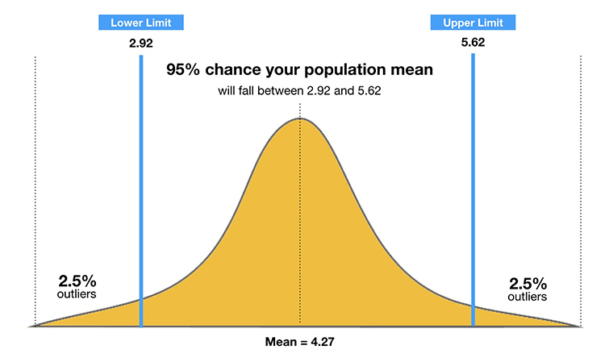

Confidence level:

The percentage of all possible samples that can be expected to include the true population parameter.

E.g. 95% confidence level implies that 95% of the confidence intervals would include the true population parameter.

Justification:

When the confidence level increases the confidence interval also increases(width); when this increases the accuracy also increases.

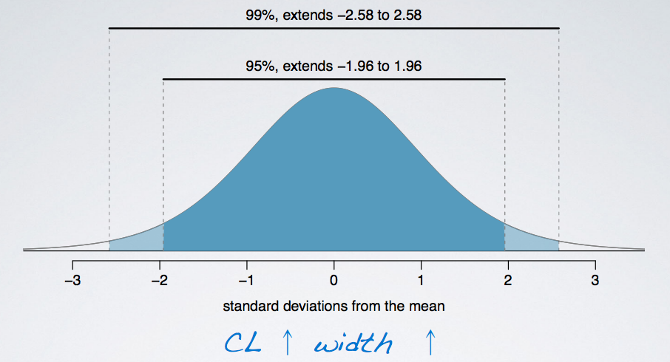

Higher confidence🡪larger margin of error🡪more accuracy

Lower confidence🡪smaller margin of error🡪less accuracy

(Margin of error🡺max diff b/w the true parameter and the sample estimate of that parameter)

Conclusion:

More the confidence interval gives more accuracy